CMPT307N – Internetworking
Syllabus updated – January 4, 2022
Andrew Tokash
Section 112 : Tuesdays 2:00-4:45PM HC 0006

Faculty Availability

Office Hours: Hancock 3002
“Going to office hours is one of the pieces of advice that is most often given, but rarely taken.”
- Ellen Anderson

- I have office hours at least three days each week. Walk-ins welcome, but preference given to scheduled appointments. To see the current schedule: calendly.com/atokash
- I prefer ILearn messages (rather than email) for communications, as it keeps all of a course’s materials and communications in one place. If you do email me, please include the course and section number.
- Please use ILearn forum/discussion for general questions on material, expectations, etc. and for posting interesting topics for class discussion

Catalog Course Description

This course provides students with experience in setting up, configuring, and troubleshooting internetworks. This course builds on concepts from the prerequisite course CMPT306 - Data Communications.
This course introduces, describes and discusses the architecture, structure, functions, components, operations of routers and switches, and models of the Internet and other computer networks. The principles and structure of IP addressing and the fundamentals of Ethernet concepts, media, and operations are introduced. Students learn how to configure and troubleshoot routers and switches and resolve common issues with routing protocols, VLANs, inter-VLAN routing and data link protocols in both IPv4 and IPv6 network environments. The course uses both simulation software and hands-on physical devices.

By the end of the course, students will be able to build simple networks, perform basic configurations for routers and switches, implement IP addressing schemes and troubleshoot various network technologies.

Texts and Additional Resources

- Odom, Wendell. CCNA Routing and Switching 200-301 Official Cert Guide (2 volumes), Cisco Press (this book is the required)
- Cisco Packet Tracer - Simulation software, free download. (Version 8)
- Empson, Scott. CCNA Routing and Switching Portable Command Guide, 4th Edition, Cisco Press (recommended but not required)
Additional Online Resources:
- http://cisco.netacad.com http://www.cisco.com
- http://www.ieee.org http://www.ietf.org
- http://www.iana.org http://www.tiaonline.org

Weekly Modules

Each week I will post in the ILearn resources the current module’s resources:
- A ReadMeFirst file with due dates, course progress, module contents, student requirements, and other information
- The PPT slides, which I am updating to include more information
- Videos posted in my shared Dropbox Library
- Modules may also include short videos with lectures and/or demonstrations
- Weekly quizzes, assignments and projects which will be due the following week

Educational Approach / Philosophy of Education

I hope to provide a challenging learning experience that build foundational knowledge and provide students with ‘deep learning’. This will be a collaborative endeavor, and requires self-learning students who care about the material. A truly successful course is not just about getting a grade; it should change, enhance or transform your life (L. Dee Fink).

“The value of a college education is not the learning of many facts but the training
of the mind to think." - Thomas Edison

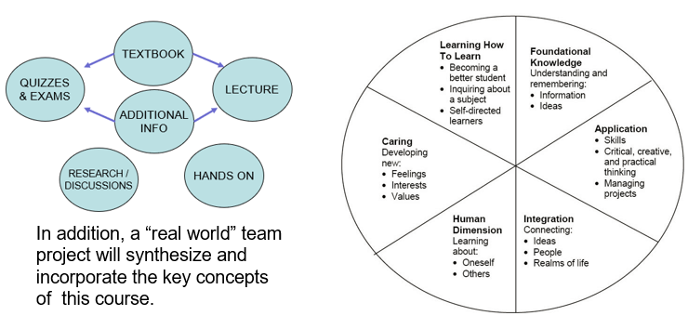

Computer Science Department Goals

“Today, companies expect not only technical hard skills, but also so-called professional skills [which] include communication, project management, conflict management, diversity management and teamwork.” – Marc-Oliver Pahl

- Prepare students for employment in a technology field or for graduate study in a technology field.
- Provide students with both theoretical knowledge and skills-based proficiencies in the five core technology competencies: programming, hardware, data communications, data management, and systems/software analysis and design.
- Provide students with fundamental knowledge of business administration and management so that graduates will be able to work effectively within businesses and other organizations.
- Develop interpersonal skills for working effectively on teams.
- Develop effective written and oral communication skills.

Course Objectives

- Understand standard networking protocols and principles -the basis of data communications transfers. [1,2]
- Understand hardware used to create local area networks, wide area networks, internets, and be able to design hardware/software infrastructure. [1,2,3]
- Understand software and device commands used to perform data communications exchanges. [1,2,3]
- Understand and describe the importance of addressing and naming schemes at various layers of data networks in IPv4 and IPv6 environments. [1,2,3]
- Design, calculate, and apply subnet masks and addresses to fulfill given requirements in IPv4 and IPv6 networks [1,3]
- Build a simple Ethernet network using routers and switches, using Cisco command-line interface (CLI) to perform basic router/ switch configurations. [1,2,3,4]
- Understand business requirements and security issues, and configure ACL’s. [1,2,4]
- Configure and troubleshoot static routing and default routing (RIP and RIPng), Dynamic Host Configuration Protocol (DHCP) and Network Address Translation (NAT) operations. [1,2,3]
- Work in teams to create working topologies using racked hardware. [4]
- Submit and present professional-level assignments and other work. [5]

Note: A detailed list of ‘core competencies’ is listed in the iLearn resources (file “Class Notes”). This list details, by weekly module, expected acquired knowledge topics and demonstratable skills.

Course Evaluation

Students are assessed through exams, practicum, self-assessment quizzes, assignments, presentations and projects. Written projects and presentations will be used to assess their interpersonal, written and oral skills.

25% Labs and Assignments
30% Exams
30% Lab Practicum
10% Class Attendance
5% Weekly Self Assessment Quizzes

The aggregate grading policy for grading is a modified version of Marist’s grading schema, and will be displayed in the iLearn gradebook. Please continuously monitor your iLearn grade and contact me for any questions. Do not wait until final weeks to bring up any issues.

 | 94 A | 90 A-
87 B+ | 83 B | 80 B-
77 C+ | 73 C | 70 C-
65 D+ | 60 D

The weekly quizzes will be based primarily on the textbook, which I expect students to read.
All assignments, labs and quizzes are to be submitted by the due date specified. Late submissions may NOT be accepted! Also, I generally do not provide extra-credit or make-up assignments. These policies are in place to prepare you for the expectations of future employment.
Make-up opportunities for assignments, assessments, and exams are provided only for verifiable extenuating circumstances cleared through CAAS. Acceptable excuses for late submission of assignments include situations covered in the Student-Athlete Handbook, illness, and serious extenuating circumstances (e.g., death in the family, serious illness).

Coursework Submission Guidelines

Assignment, lab and project files must be submitted into ILearn. Documents must follow a standard naming convention and have proper page headers. Refer to the file “Submission Guidelines” in the Ilearn Resources section.

The guidelines file also lists information on using/citing references and the difference between a 90% A and a 100% A.

Learning Disabilities

Students have all types of learning disabilities. It is your responsibility to notify the professor in the beginning of the semester in order to make sure you are successful within this course! If you’re unsure whether you have a learning disability, make sure you see Special Services within Donnelly as soon as you suspect your disability!

Academic Honesty

Faculty will uphold and enforce the general policies of this institution on academic honesty and plagiarism. All examinations, assignments, and projects are subject to the standards of academic honesty as described in the Student Handbook and/or other related publications.

Plagiarism is suspected if an assignment calling for independent design and implementation results in two or more solutions that differ only by simple mechanical transformations. Cheating is suspected if an assignment calling for independent design and implementation results in a solution that cannot be explained to the instructor, in terms of either general method or specific techniques. If you are suspected of cheating, you will be asked to explain the work. If you cannot you will be ejected from the course with a failing grade, in addition to any other forms of recourse available to the instructor as specified by the Student Handbook.

You are encouraged to discuss the course material, concepts, and lessons with other students in the class. However, your labs, exams and discussions must be your own work. If you are caught copying or otherwise submitting material that is not solely your work, you will fail the course and a letter will be sent to the department chair.

Please consult the ACM code of ethics. See www.acm.org/constitution/code.html.

Coursework Submission Guidelines

Assignment, lab and project files must be submitted into ILearn. Documents must follow a standard naming convention and have proper page headers. Refer to the file “Submission Guidelines” in the Ilearn Resources section. The guidelines file also lists information on using/citing references and the difference between a 90% A and a 100% A.

Textbooks and PowerPoint Slides

Good note taking is a key skill for active learning, and reading the textbook is a requirement for the course. For these reasons I will release in Ilearn only the Power Point slides of material that is not from our textbook. (There are copyright restrictions, as well).

Important Note

In the event of a campus wide ‘pause’, we will be forced to hold classes remote. If that happens, students are expected to Zoom in and keep their video feeds live, and will be responsible for any class work covered during the normal class time. Also, in the event of inclement weather, we will hold classes remote!

Tentative Class Schedule

The below class schedule is tentative and will be updated week by week. It will be posted in iLearn and will be reviewed at the start of each class. (The schedule also includes due dates for assignments, labs and quizzes.) New topics may be added. Winter closings and delays may also affect the schedule - check iLearn for any notifications from me.

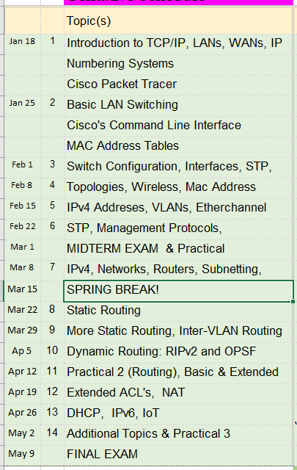

Diversity and Inclusion

The college's academic mission is immeasurably enriched by students with diverse experiences. Our finest efforts as intellectual beings heavily rely on the exchange of ideas. Interactions in our classrooms among persons and groups with diverse backgrounds, ideologies, and experiences facilitate these efforts by allowing us all to be more reflective about the varied historical and social contexts in which we work and learn.

In this course, we will challenge each other’s thinking while working collaboratively to ensure that the classroom is a space of safety and bravery. Our classroom offers an environment where individuals of varying opinions, experiences, and backgrounds can freely learn without fear of being silenced.
Aspects of diversity include, but are not limited to, race, ethnicity, color, nationality, sex, gender, gender identity, gender expression, class, sexual orientation, religion, age, ability, and veteran status. Students who would like to be identified in a manner other than what is indicated on the course roster can contact me privately to indicate name, pronoun and any other preferences they may have.

Steps to Getting an “A”

In my opinion the single best thing you can do to learn the material and get an A is to practice, practice, practice. Using Cisco’s “packet tracer” software you can re-run labs and experiment. I strongly recommend doing several simulations on several different days between classes so you (a) fully grasp the concepts and (b) learn the device configuration commands. Experiment! Play around! Fail and debug why it fails!

Two other recommendations: Create a concise FAQ with the switch and router configurations, and Packet Tracer shortcuts. Before creating a simulation draw out the configuration and label all devices including their MAC/IP address.
Other recommendations:

- Attend classes. If something is unclear ASK for a better/different explanation.
- Be an active student. Take notes, listen, speak, ask questions.
Refer to: http://www.dartmouth.edu/~acskills/success/notes.html
- Do a quick review of chapters BEFORE the class to identify confusing sections.
- Read the chapter and review each section’s TEST YOUR UNDERSTANDING questions.
- Do all assignments and submit them on time with proper formatting and citations. Begin assignments early in case you have questions.
- Do not copy assignments from other students, the Internet or any other source.
- Take your time with SELF ASSESSMENTS. Review material BEFORE taking the quiz.
- Study for the exams. Use the Core Competencies as a study guide.
- Work with other students and take advantage of office hours.
- Monitor your grades weekly.
- Use a flashcard application (ex: Quizlet) to help you study. Use the publisher’s flashcards if available.
- Participate fully in team projects!
- If you have any questions, confusion or issue, address them immediately. Do not wait until the end of the semester to do so.

Changes to This Syllabus (highlighted in blue)

01/04/2022 Preliminary syllabus for 2022

End of Document

The reference number in brackets [ ] indicates the department goal that is being met with the fulfillment of the objective.

